**9. Aim: Run a basic Word Count Map Reduce program to understand Map Reduce Paradigm.**

**Running the WordCount program**

First we need to copy the data files from the local file system to HDFS.

Step 1:Execute the commands below to copy the input files into HDFS.



**hadoopfs -mkdir /user/biadmin/input**

**hadoopfs -put /home/biadmin/bootcamp/input/lab01_HadoopCore/MapReduce/*.csv/user/biadmin/input**

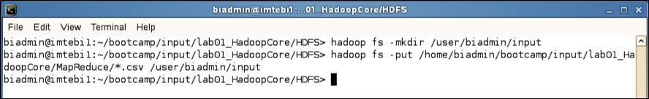

**Copy input files into HDFS**

Step 2: Review the files have been copied with the following command:



**hadoopfs -ls input**

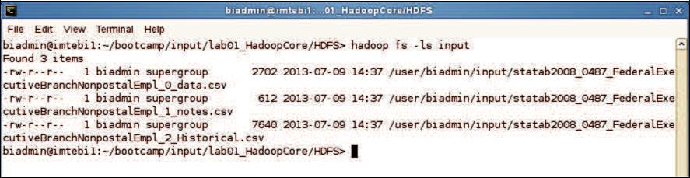

**List copied files into HDFS**

Step 3: Now we can run the wordcount job with the command below, where “/user/biadmin/input/” is where the input files are, and “output” is the directory where the output of the job will be stored. The “output” directory will be created automatically when executing the command below.



**hadoop jar /opt/ibm/biginsights/IHC/hadoop-examples-1.1.1.jar wordcount /user/biadmin/input/ output**

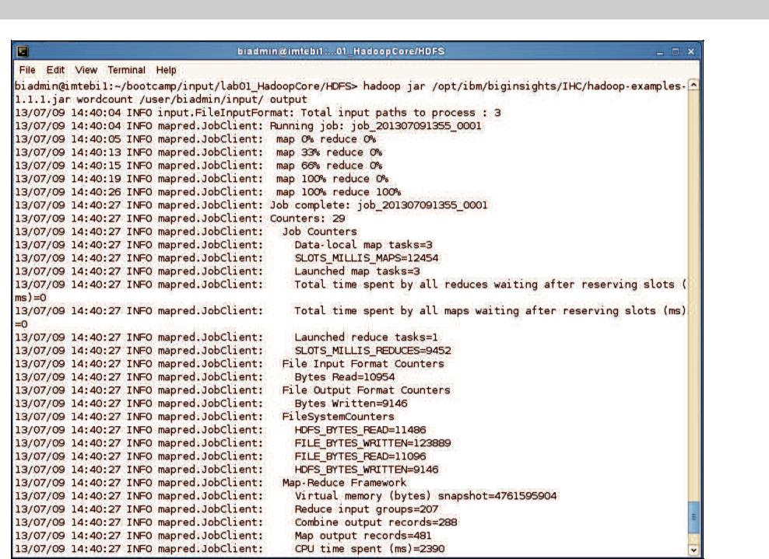

**Word Count Map Reduce job running**

Step 4: Now review the output of step 3:

In this case, the output was not split into multiple files.



**hadoopfs -ls output**

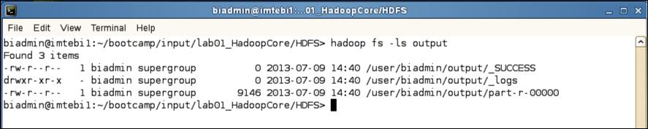

**MapReduce result files**

Step 5: To view the contents of the part-r-0000 file issue the command below:



**hadoopfs -cat output/*00**

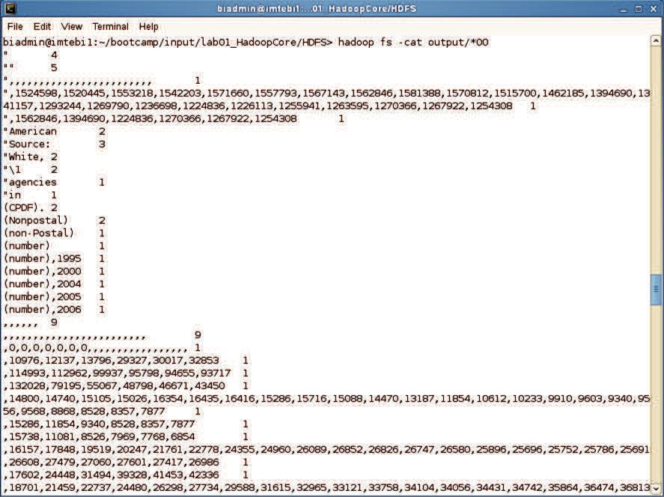

**Map Reduce output**

**MapReduce output**